**TALK ABOUT IT COMMUNICATIONS BOOK SPONSORSHIP PROGRAM**

This program is aimed at helping to end the silence and prevent Child Sexual Abuse. Sponsorship will allow Talk About It Communications to donate ‘Should I Tell My Secret?’ books on your behalf to various organizations. The levels of sponsorship are listed below at a discounted cost.

**Levels of sponsorship:**

$500.00 will allow Talk About It Communications to donate 32 books

$ 1000.00 will allow Talk About It Communications to donate 65 books

$ 1500.00 will allow Talk About It Communications to donate 98 books

$2000.00 will allow Talk About it Communications to donate 131 books

Other amount specified

All ‘**Should I Tell My Secret?**’ books will be donated to schools, libraries, sexual abuse prevention organizations, or shelters. Along with each book donated there will be a book marker created with a company logo (provided the sponsoring company provides a digital company logo).

Please print this form, check desired level of sponsorship, and sign with date. Please make cheque out to “**Talk About It**.” Mail this form and cheque to:

Collette Sinnott – Talk About It Communications

160 West Creek Landing

Chestermere, AB

T1X 1R8

Thank you for your sponsorship and help in fighting this Silent Epidemic!

For more information please visit [**www.collettesinnott.com**](http://www.collettesinnott.com) or phone Collette at 403-852-7194.



____________________________(Signature)

____________________________(Please print name)

______________(Date)

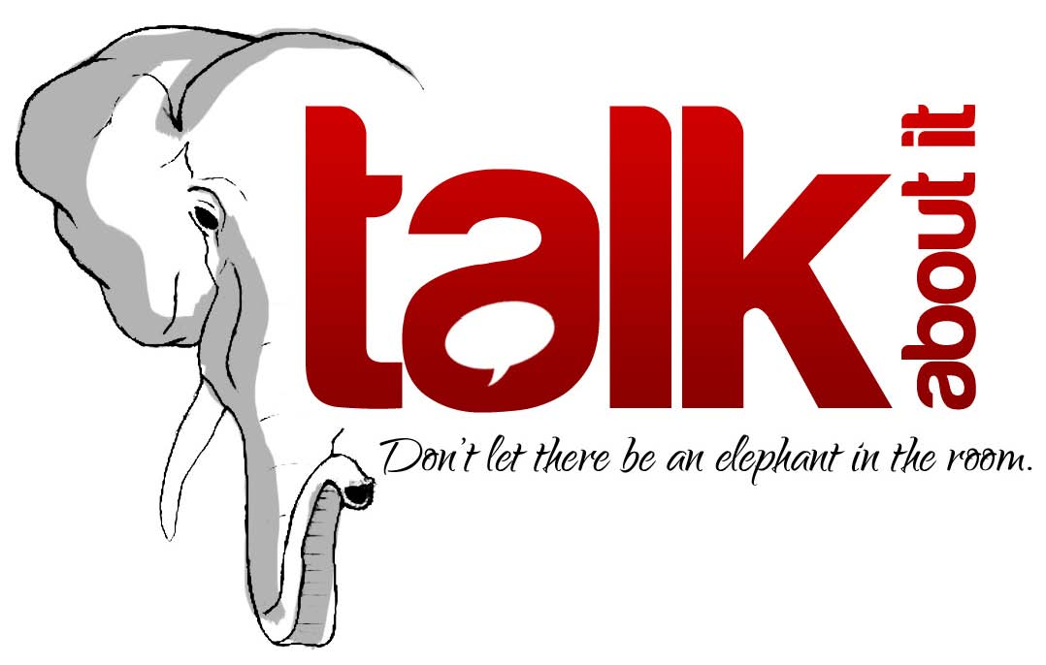

**Contact: Collette Sinnott** [**www.collettesinnott.com**](http://www.collettesinnott.com/)

403-852-7194 [**info@collettesinnott.com**](mailto:info@collettesinnott.com)